Magnitude Gold



Theming process

Resolutions

Each Solid bullet point is a folder containing the different images below them. Each image has a resolution associated to it.
Theme Resolutions (Names should also be the same as depicted below):
- MPDI 320x480
  - CMSFeedbackResponse.png – 526x526
  - CMSLogo.png – 492x142
  - footer.png – 320x60
  - logohome.png – 394x113
  - logologin.png – 497x142
  - mainbg.png – 320x480
  - splashscreen.png – 320x480
  - WebBg.png – 2560x1600
- HDPI 480x800
  - footer.png – 480x88
  - logohome.png – 394x113
  - logologin.png – 497x142
  - mainbg.png – 480x800
  - splashscreen.png – 480x800
- XHDPI 720x1280
  - footer.png – 720x140
  - logohome.png – 394x113
  - logologin.png – 497x142
  - mainbg.png – 728x1280
  - splashscreen.png – 728x1280
- XXHDPI 1080x1920
  - footer.png – 720x140
  - logohome.png – 394x113
  - logologin.png – 497x142
  - mainbg.png – 728x1280
  - splashscreen.png – 728x1280
- 640x960
  - footer.png – 640x118
  - logohome.png – 394x113
  - logologin.png – 497x142
  - mainbg.png – 640x960
  - splashscreen.png – 640x960
- 640x1136
  - footer.png – 640x118
  - logohome.png – 394x113
  - logologin.png – 497x142
  - mainbg.png – 640x1136
  - splashscreen.png – 640x1136
- 768x1280
  - footer.png – 720x140
  - logohome.png – 394x113
  - logologin.png – 497x142
  - mainbg.png – 728x1280
  - splashscreen.png – 728x1280
- 750x1334 (New)
  - footer.png – 750x124
  - logohome.png – 160x130 564x180
  - logologin.png – 250x200 560x350
  - mainbg.png – 750x1334
  - splashscreen.png – 750x1334
- 1242x2208 (New)
  - footer.png – 1242x186
  - logohome.png – 238x190 933x300
  - logologin.png – 372x297 840x525
  - mainbg.png – 1242x2208
  - splashscreen.png – 1242x2208

How images are displayed

Mobile Application

Splash screen when application launches:
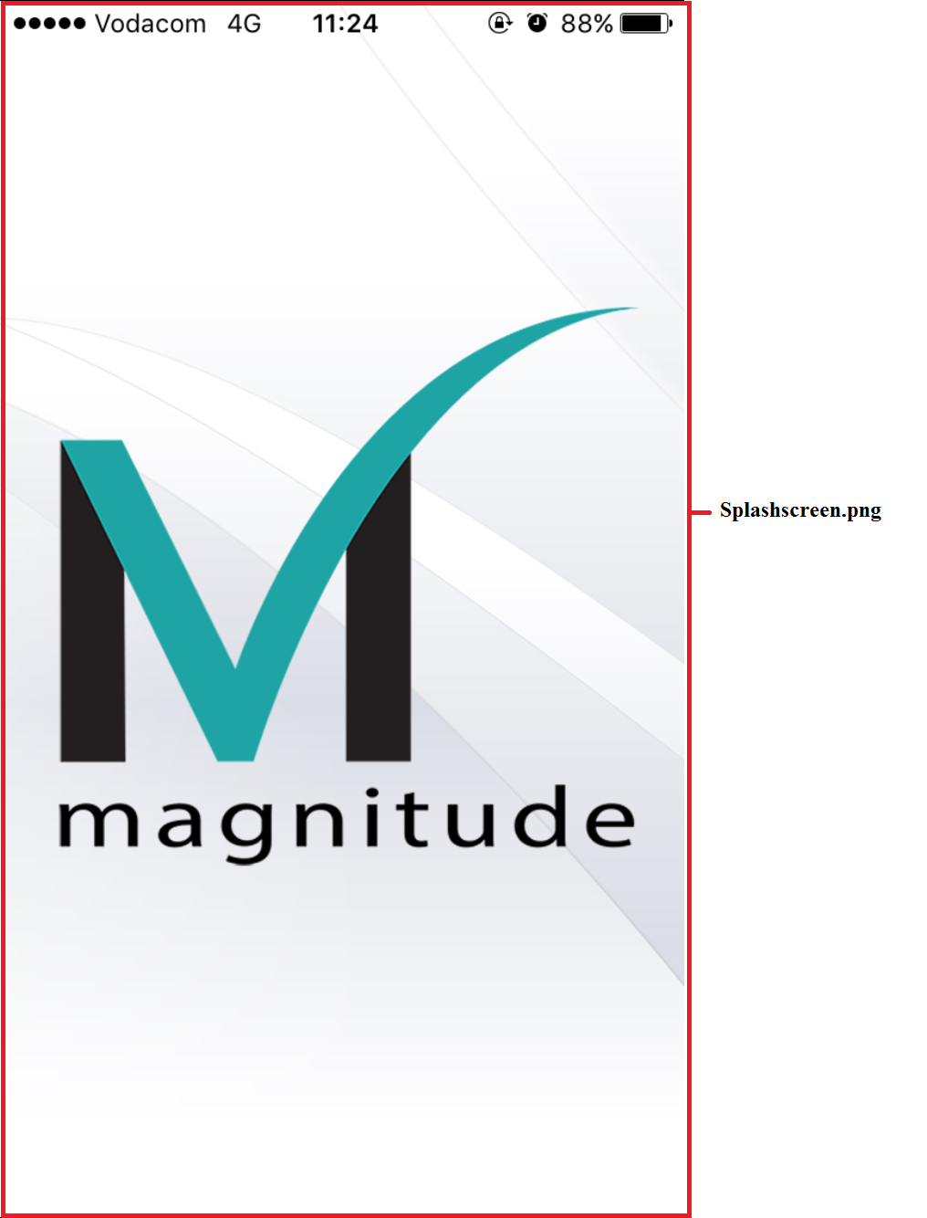

Application login screen:
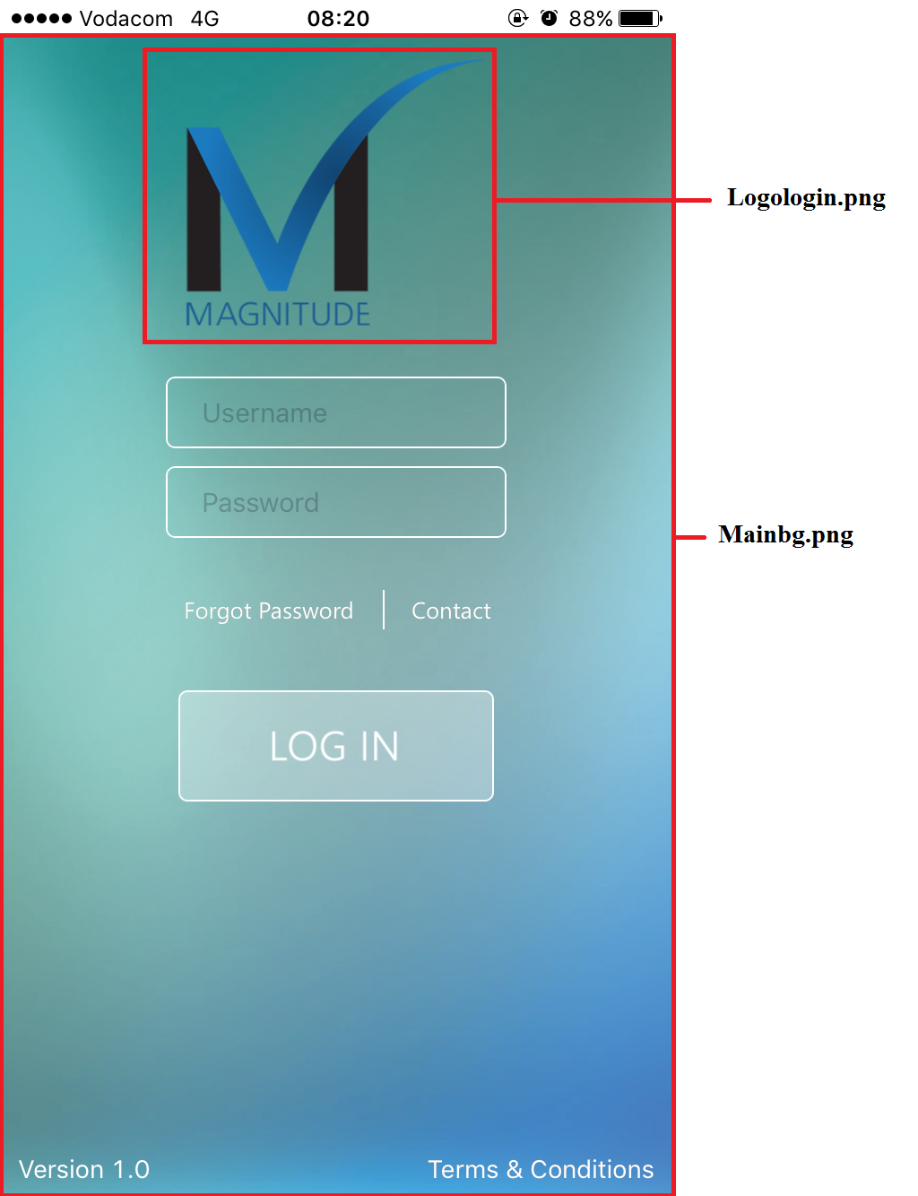

If you view the activity list:
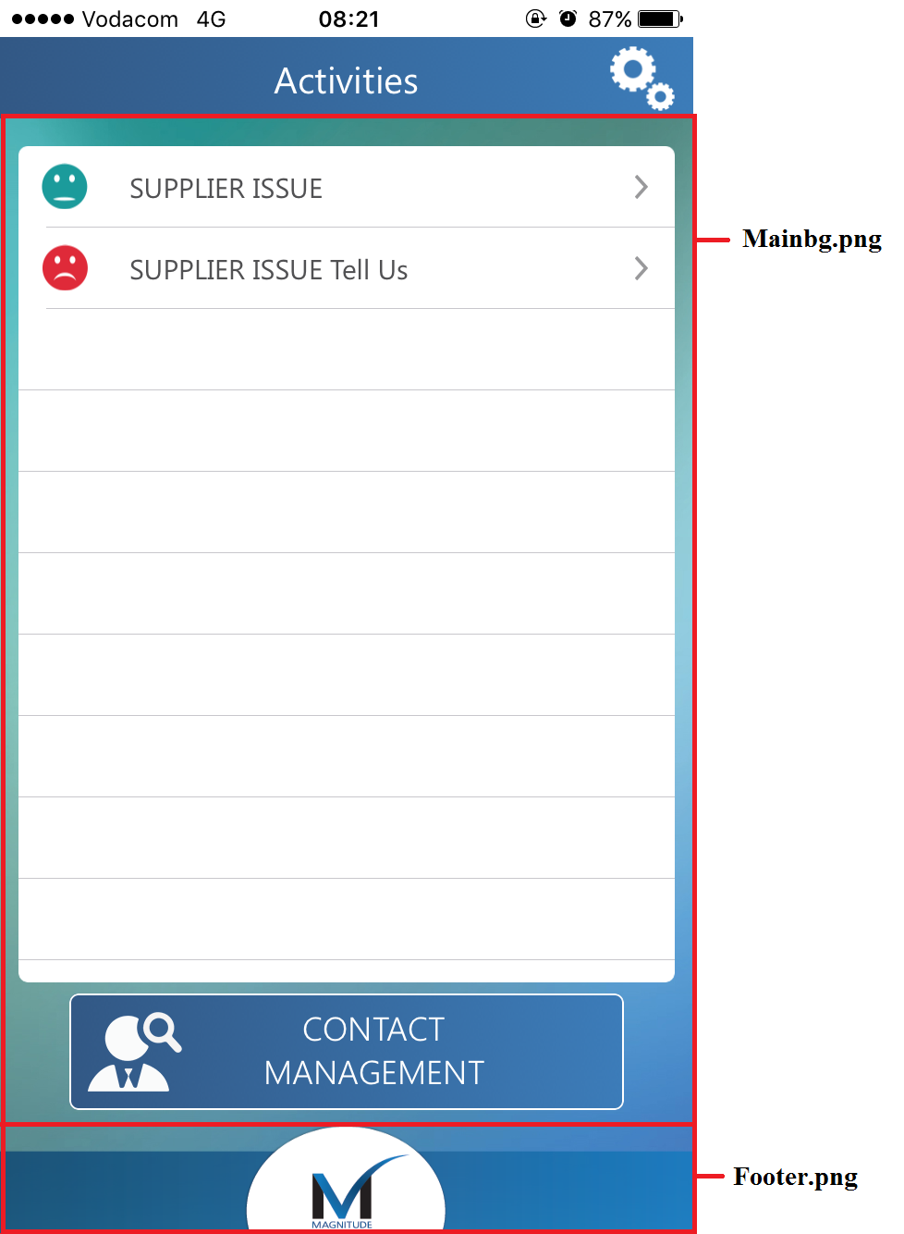

Going into the Activity:
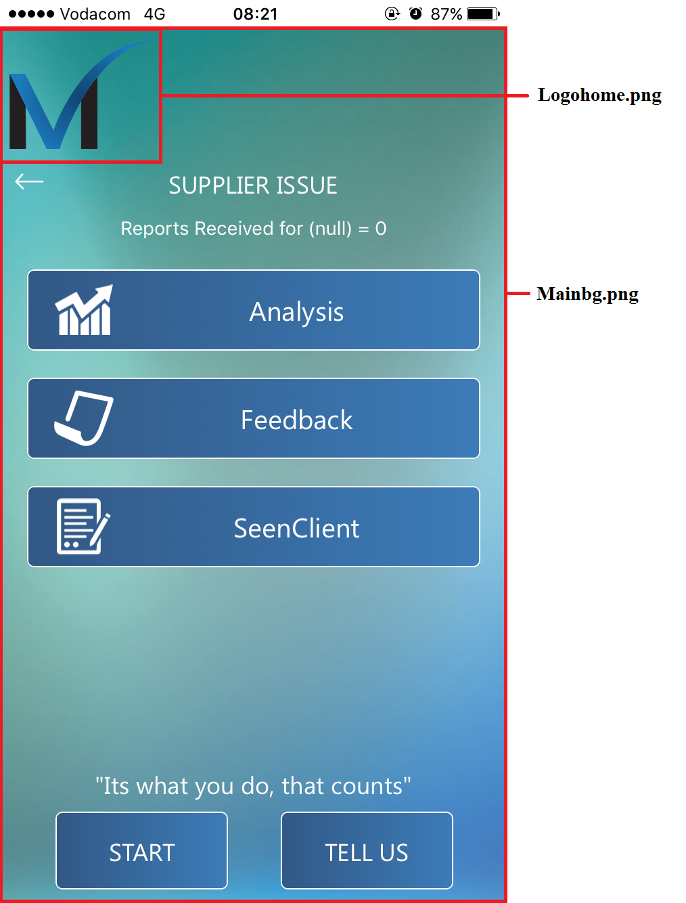

.Mobi first time view:
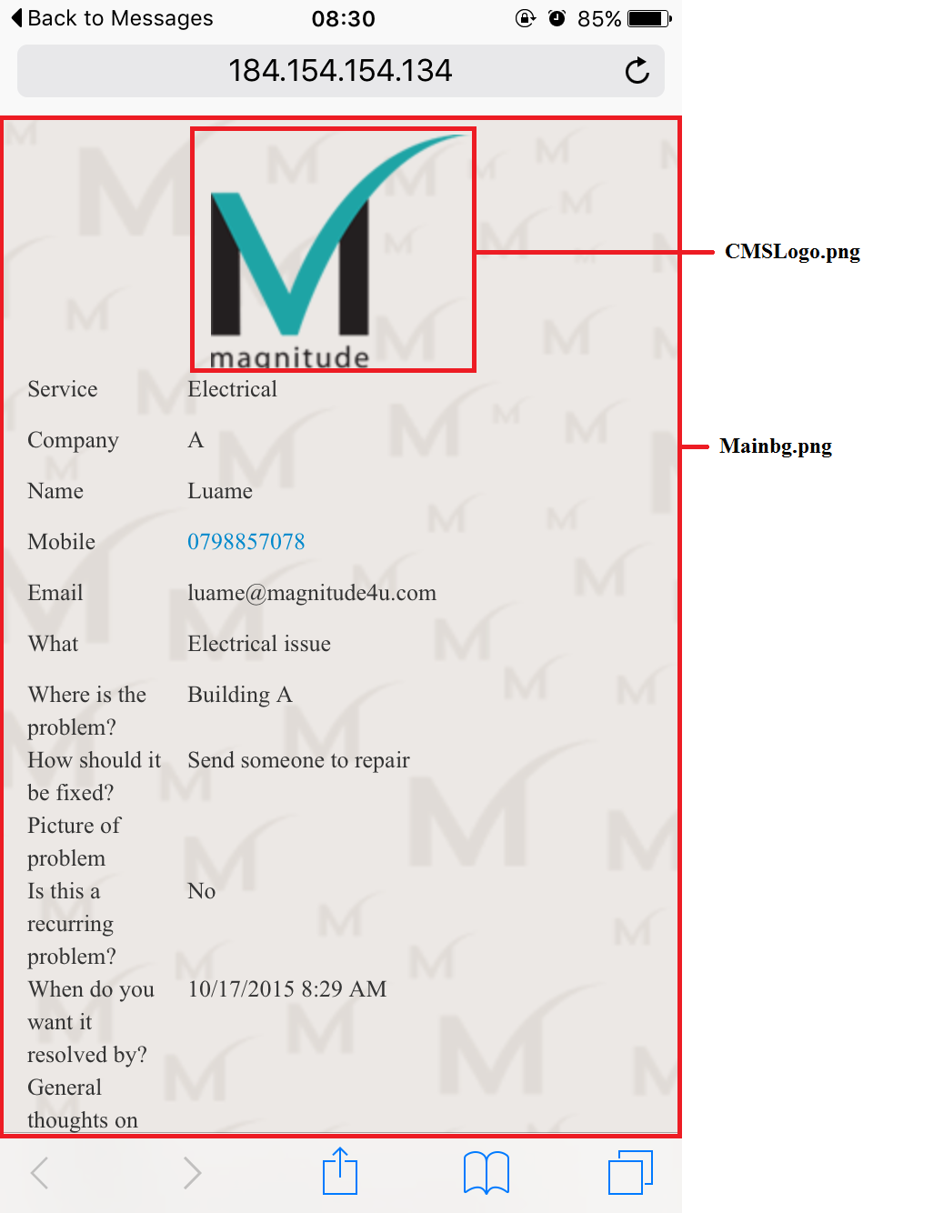

.Mobi Feedback submitted:
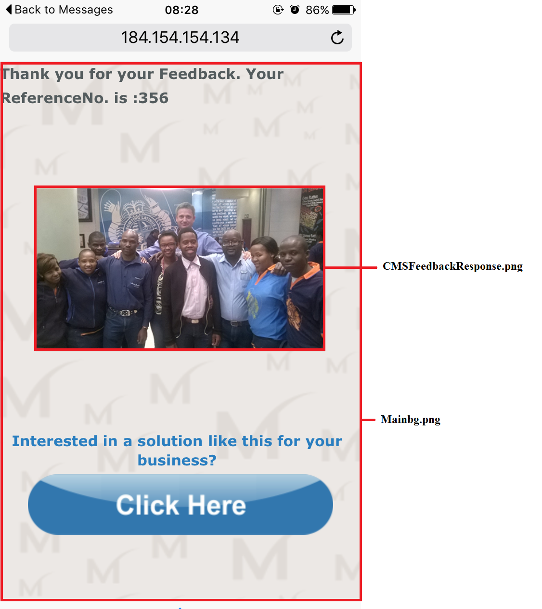

Web Application

The web application has the same convention as the application, the main difference is the background used. The mobile application uses Mainbg.png, but the web application uses Webbg.png.

Web login:
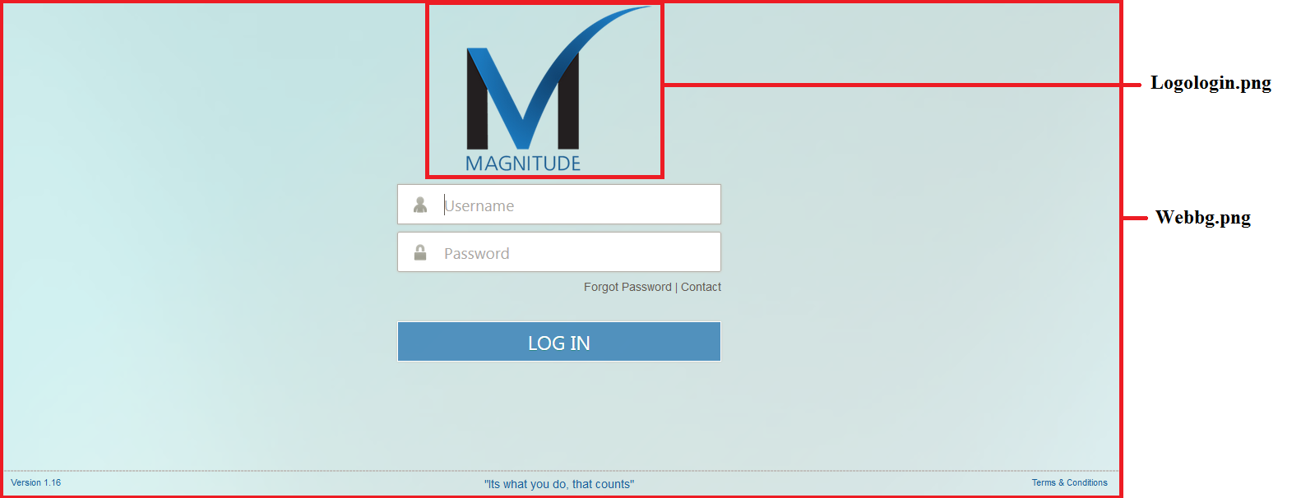
Web Activity list:
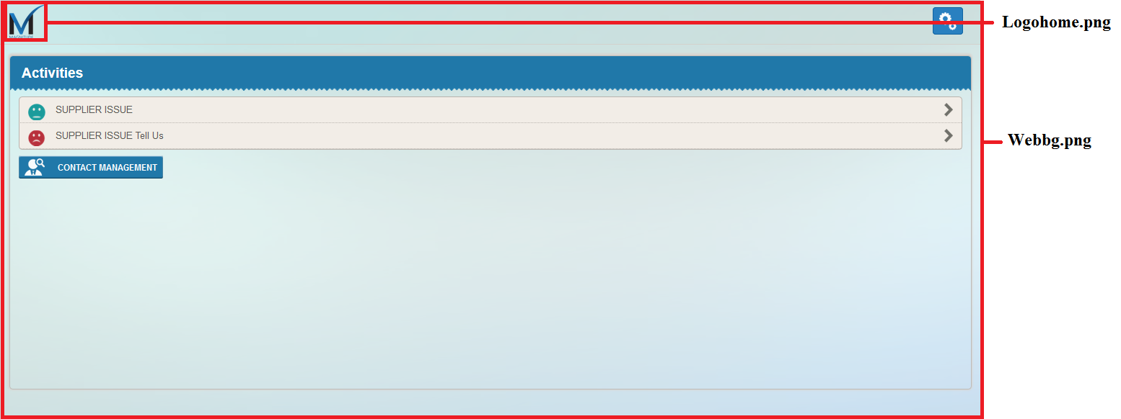

Example Images

CMSFeedbackResponse.png:
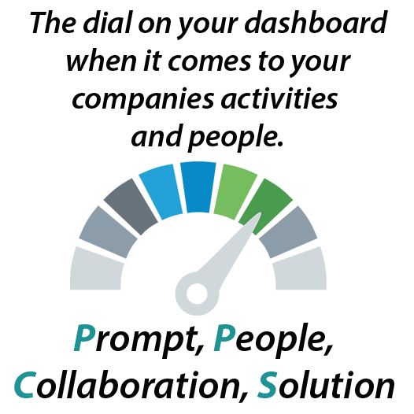

CMSLogo.png:


footer.png:


logohome.png:

logologin.png:


Mainbg.png:


Splashscreen.png:


WebBg.png:


