26 July 2018

ANNOUNCEMENT

It is with deep regret that we record the death of Mr. Tshepho S. Lebepe on 24 July 2018.
Mr. Lebepe joined the company on 13 June 2005 and, at the time of his death, held the position of Auxiliary Operator in the Metal Finishing Department of Hulamin Extrusion, Olifantsfontein.

On behalf of management and all employees we extend our sincere sympathy to the Lebepe family in their bereavement and sad loss, which we also share.

Funeral Arrangements
His funeral will be held on Saturday 4 July 2018 at his hometown,

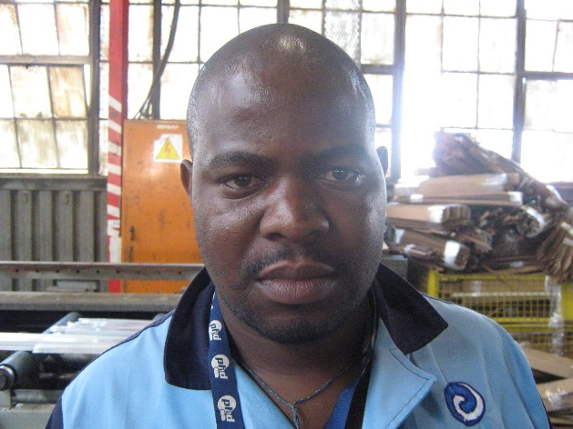
Mr. Tshepho S. Lebepe

Signature

N. Ngcobo
HR. Dept

Distribution: All Notice Boards, PMB , Hulacon and Extrusions Midrand

