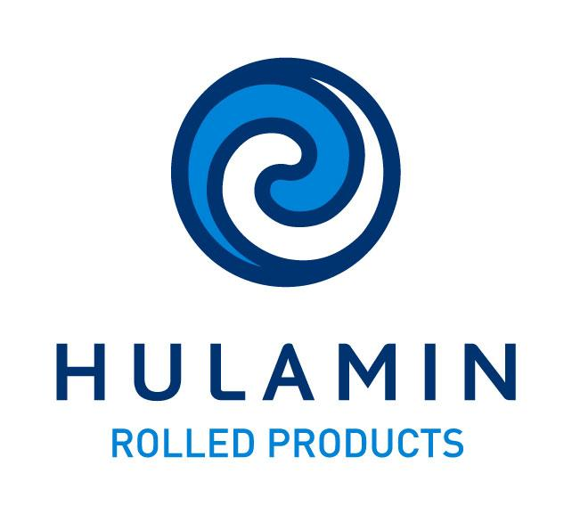

Manager : Process Engineering

Applications are invited from suitably qualified and experienced persons to fill the above
Vacancy that exists in the Manufacturing team.

The core responsibilities of the position include:

- Taking ownership of the process control process. This includes the continuous improvement of the process control system and performance thereof.
- Managing the adoption and continual improvement of the Quality Information System (QIS), which includes control plans, control charts and automatic monitoring of deviations.
- Managing the specialized technology team, which includes systems such as surface inspection and gauge / profile measurement and control.
- Managing the recovery system, including the continual development of systems to manage recoveries. Play an active role in area and product recovery OPPs.
- Engaging in active leadership and routine monitoring, which will include the leading of VFLs and frequent interaction with manufacturing area personnel.
- Researching and implementing the use of applied technology to enable step change improvements to our processes.
- Training and mentoring personnel in process control and related disciplines.
- Developing strong relationships with leaders of related disciplines like process development, quality assurance and continual improvement.

The requirements for the position include:

- BSc engineering degree or Equivalent
- At least 10 years experience in a process manufacturing environment; at least 5 years experience as a process specialist or similar role would be advantageous.
- Excellent proficiency of statistics and statistical process control.
- Excellent analytic skills, with the ability to use tools such as Excel and Minitab to solve complex problems.
- Good people skills, and ability to interact with a diverse, multi-skilled team.
- Experience with advanced control systems will be an advantage.

Interested employees should complete an internal application form which is obtainable from the Human Resources Department or the intranet and direct this to Avin Bhimsen or e-mail applications to Avin.bhimsen@hulamin.co.za

Candidates who do not receive any correspondence within 1 month after the closing date may assume that their applications were unsuccessful and are hereby thanked for applying.

Closing Date: Friday 22 June 2018

